Module – 4 Lists and Hooks

1. Explain Life cycle in Class Component and functional component with Hooks

* **Class Component Lifecycle:**
* **Mounting Phase:**

**constructor():** Called when an instance of the component is being created.

**render():** Renders the component UI.

**componentDidMount():** Invoked after the component is mounted to the DOM. This is a good place to perform initial setup, like data fetching.

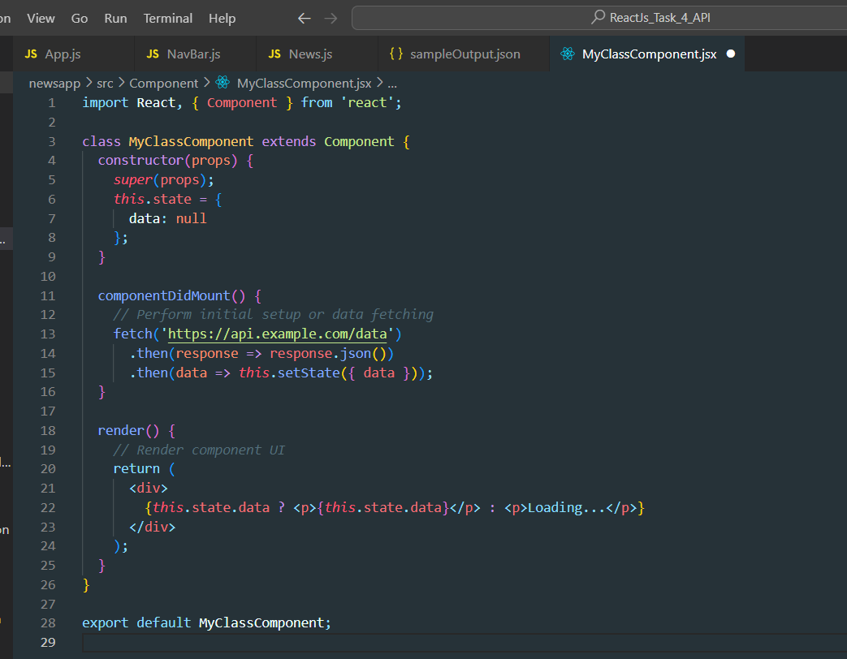

* **Updating Phase:**

**shouldComponentUpdate(nextProps, nextState):** Determines if the component should re-render. Returns true by default.

**render():** Renders the updated component UI.

**componentDidUpdate(prevProps, prevState):** Invoked after the component is re-rendered.

* **Unmounting Phase:**

**componentWillUnmount():** Invoked before a component is unmounted and destroyed. Cleanup operations can be performed here.

* **Functional Component with Hooks:**
* The **useEffect** hook with an empty dependency array mimics the behavior of **componentDidMount.**
* Another **useEffect** with a dependency on the data state variable is used to perform actions after an update, similar to **componentDidUpdate.**
* The cleanup operation is handled inside the **useEffect** by returning a function, similar to **componentWillUnmount.**

